I just wanted to talk a bit about the weather. I know you guys have been having a heat wave so I’m glad I’m not there. However, we awoke to 24 degrees and when we left for Bryce Canyon at 7:30ish, it was all the way up to 28 degrees. Bryce, on average, has 200 days per year that the temp. goes below freezing at night. It snowed here a couple of days ago. Anyway, the day does warm up to the 60’s or better.

We took probably hundreds of photos today so it was a real task to winnow them down to a reasonable amount and I’m not sure we’ve done that, so if there are too many for you just close your eyes as you go through them.

The 200 hundred days per year that there are freezing temps at night and above freezing temps in the day is what has shaped the canyon and created the hoodoos and grottos. Any moisture trapped in the crevices and dips in the canyon walls, freezes and expands, then melts, and pieces of the wall fall away. Hoodoos do start out as the arches you’ll see in the pics, then the center piece eventually falls away creating the hoodoo, often a gravity defying monument of red or white stone. The hoodoos and surrounding rock is primarily limestone tainted with iron that has rusted. The softest of the limestone weathers away leaving limestone that has been fortified with magnesium and other metals. But, eventually they too, will fall away. Fortunately, this did not happen as we were passing beneath.

We were lucky in our timing. Basically, we left for the canyon shortly after 7AM. This was to avoid having to elbow our way to good views (which worked), but it did have another advantage – animals are very active in the early morning and at dusk. We saw a group of 7 Rocky Mountain elk feeding beside our hotel, as well as several single elk feeding in the park. Then we saw a group of 10 mule deer – all very fun to see. Later in the day we saw a prairie dog scampering about – he was pretty cute considering he was a rodent.

Our day ended early as we were both feeling pretty “canyoned out”. It’s really way more than the human mind can wrap around. But, fortunately we did have enough energy to hit, yet another store featuring Indian pottery and crafts which took us back through Red Rock Canyon which is way to beautiful to ever get tiresome.

Tomorrow, off to Glen Canyon and Antelope Canyon with a destination of Monument Valley.

Debby and Dean (Did we mention that we are having a good time?)

The good stuff is below.

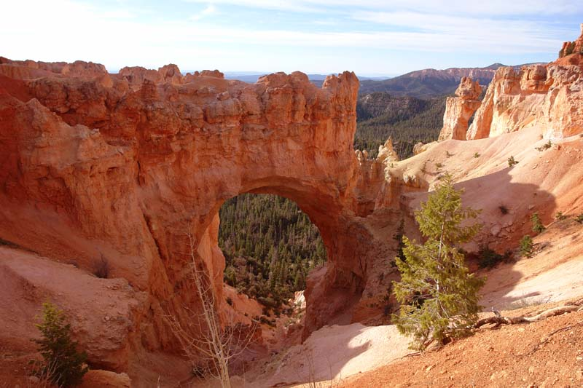

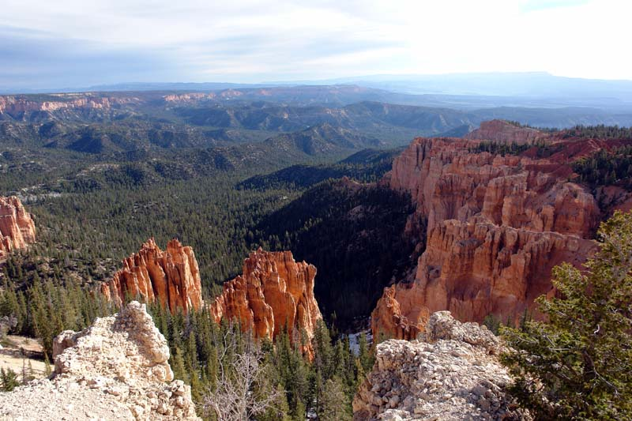

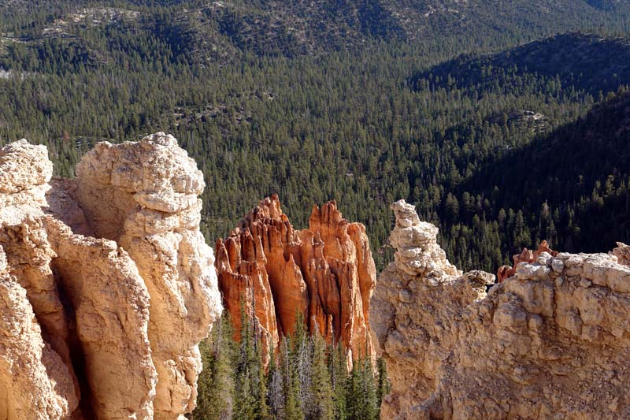

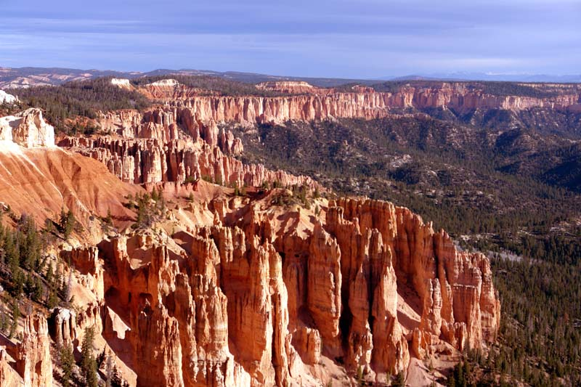

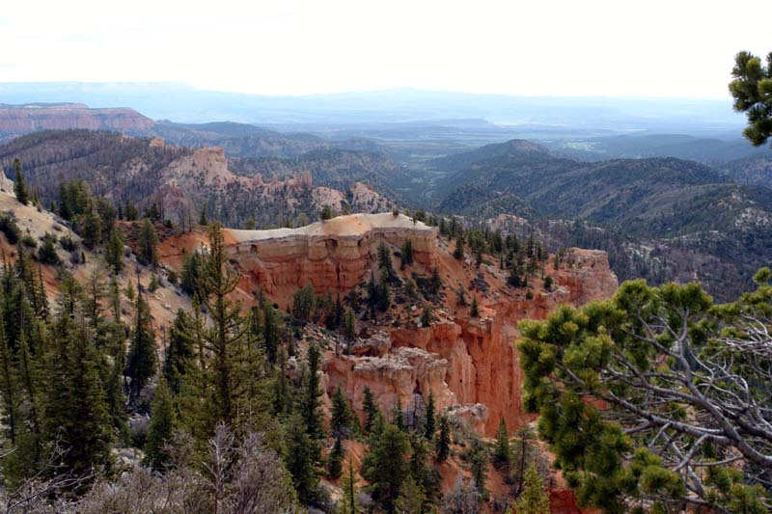

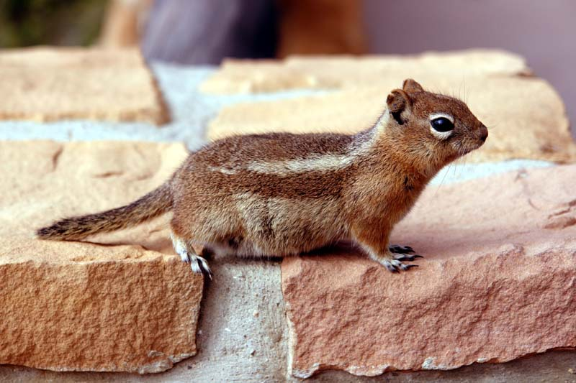

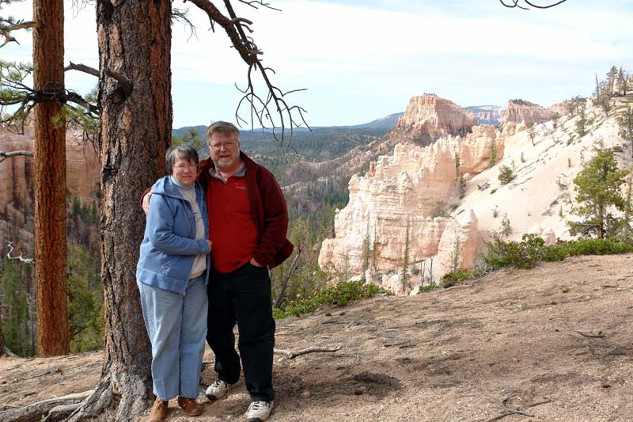

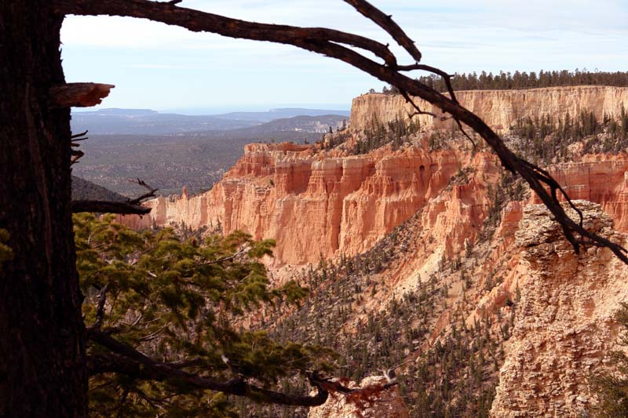

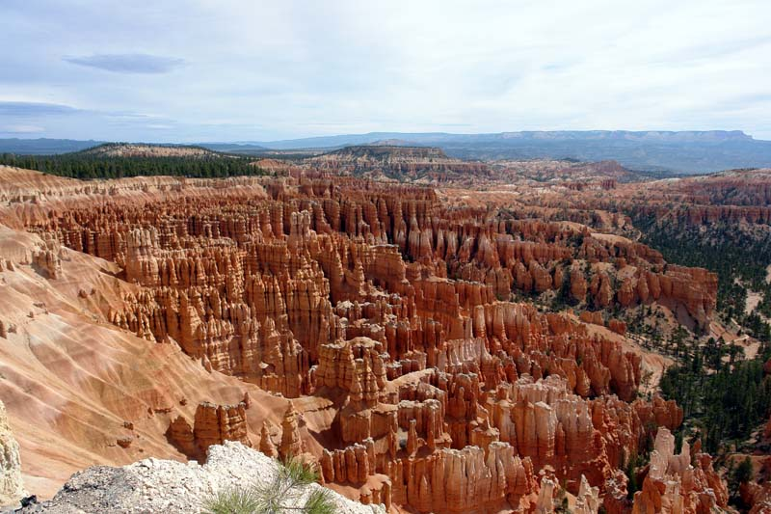

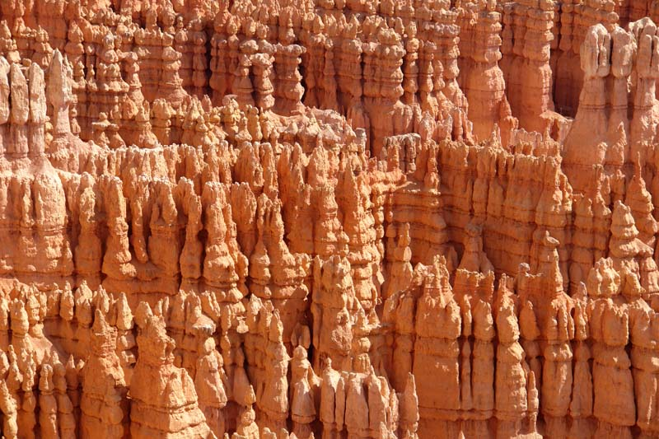

Yes, that’s snow down there.



