Today we left early in an attempt to go through Vegas after rush hour and before the big rollers woke up (no problem there!). When you’re from Augusta, Maine, even “light” Vegas traffic is a challenge. Dean is becoming a pro at it, however, and he would hold his own on Storrow Drive. Okay, that’s a slight exaggeration.

The route out of Vegas was deadly. This part of the country seems to be an enormous wasteland – very brown, very little vegetation, very boring, …, Zzzzzz. But, then we started climbing through the mountains which were deeply etched by wind (and, I suppose water) erosion. It’s actually mostly shades of brown, but very beautiful. It’s a look that a camera can’t capture because it’s all about the shadows and the depth of the etchings – a very dramatic landscape.

Then, before you could blink your eye, there were snow-capped mountains in the background, sage brush and junipers, and we were negotiating hairpin turns and steep drops. We topped out at about 7900’. As we climbed, the temperature dropped about 10 degrees to 59 in 30 minutes.

Then, the Red Canyon - talk about taking a corner and having a view that takes your breath away! The hoodoos are incredible, and as we have found with most things out here, they happen very suddenly. First they’re not there, then they are. They are very red (which the pic’s can’t quite capture; a bright orangey-red terra cotta) and very gravity-challenged. I guess that’s what takes your breath away. Why don’t they fall over? And, OMG, are they red!

Bryce tomorrow.

Coming down into Vegas (center) as we leave.

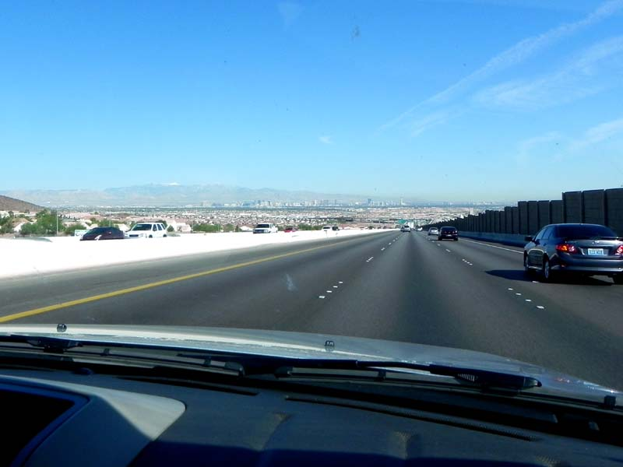

Travel views
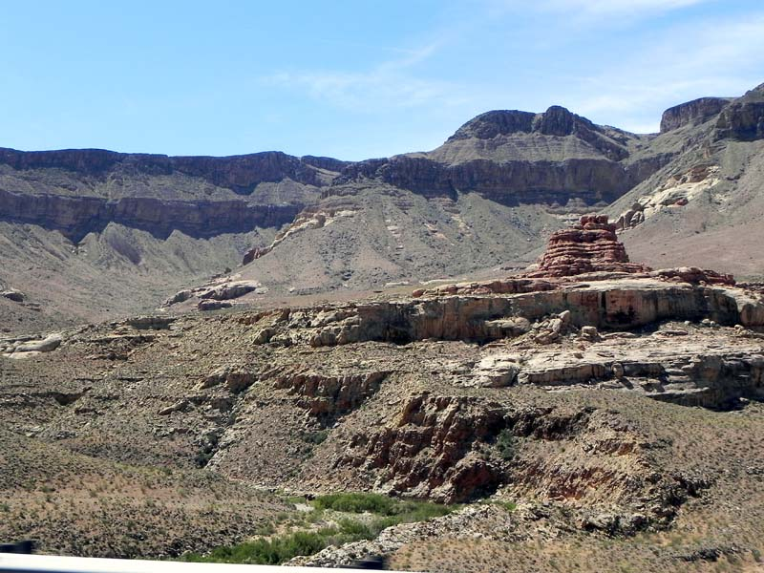

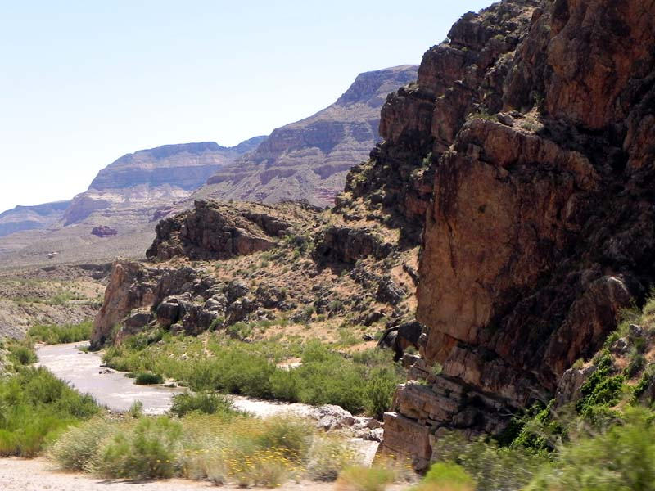

Snow on the mountains

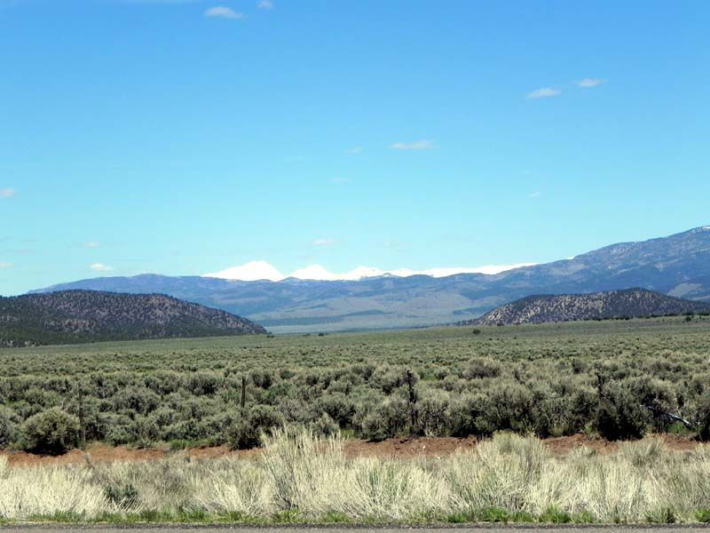

Entering Red Canyon
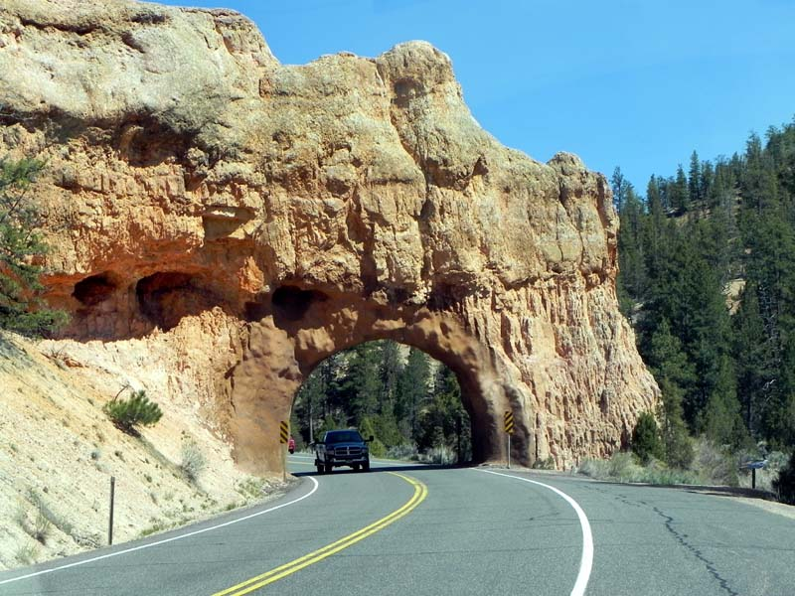

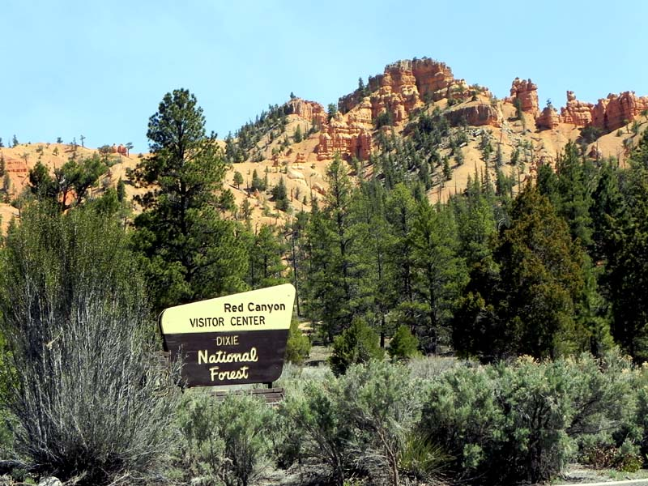

Red Canyon

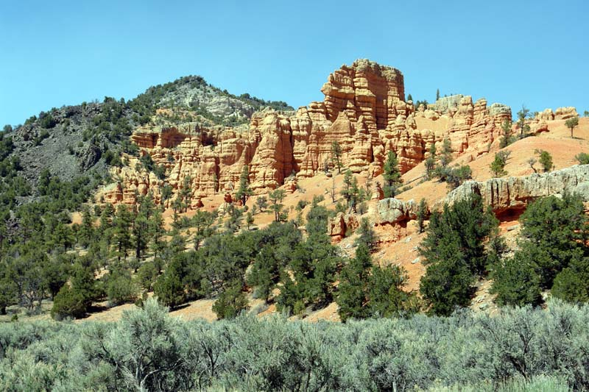

Hoodoos

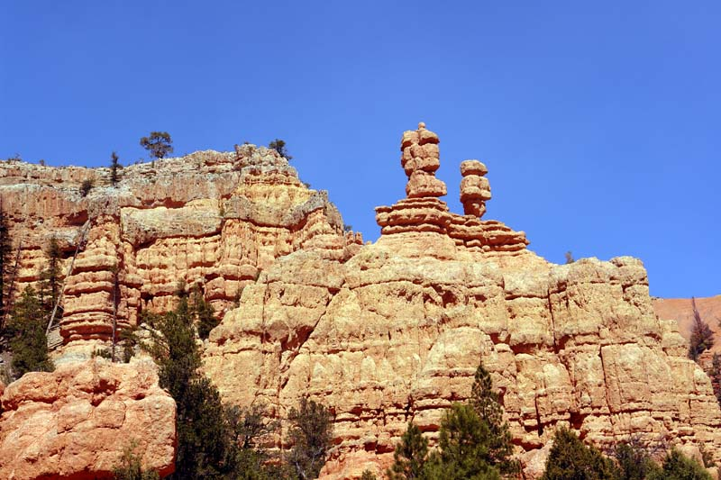

Red Canyon


