Yesterday, after a great breakfast, we headed towards Vegas arriving around 9:00 AM. We went here mostly to say we had been here but, you know, you can’t go to Vegas without doing a little gambling. So we did that.

The afternoon was slow with Debby doing the shopping thing (it’s becoming an addiction) and then we went to Lake Mead to check out the marinas. There are two large ones near the dam. Where I am standing when I took photos of them used to be under water. Because the water level is continually changing, so must the location of the marinas. We saw a beach that was about a quarter mile from the water. And launching a boat here is a different experience as you will see.

Remember poor old Ted Binion and his silver.

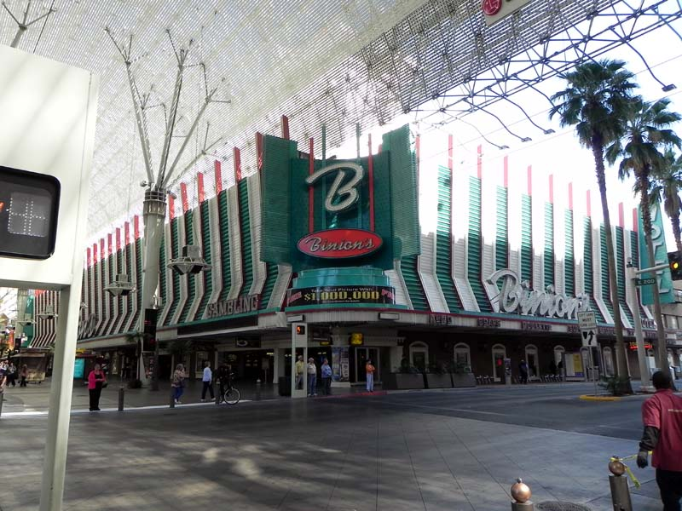
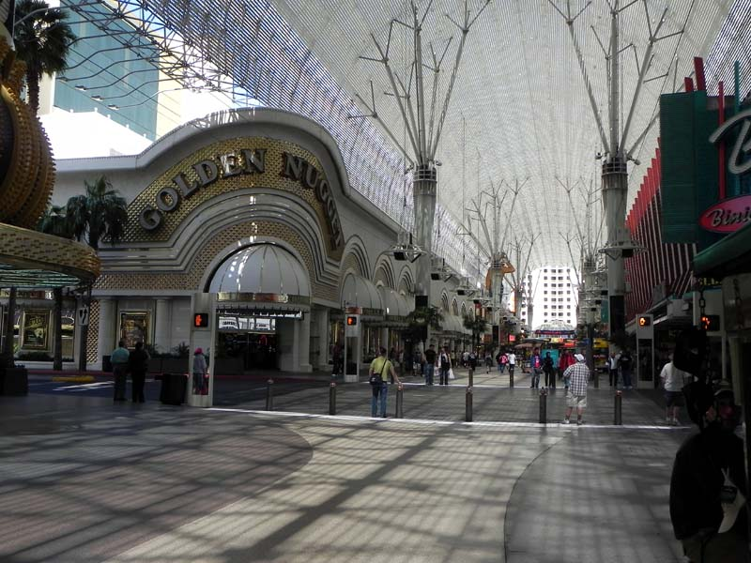

She dumped a bundle.
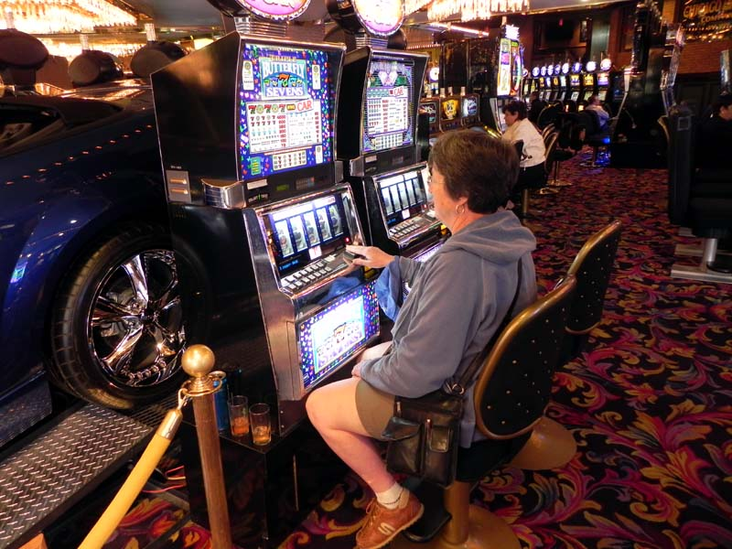

Here I am winning big.
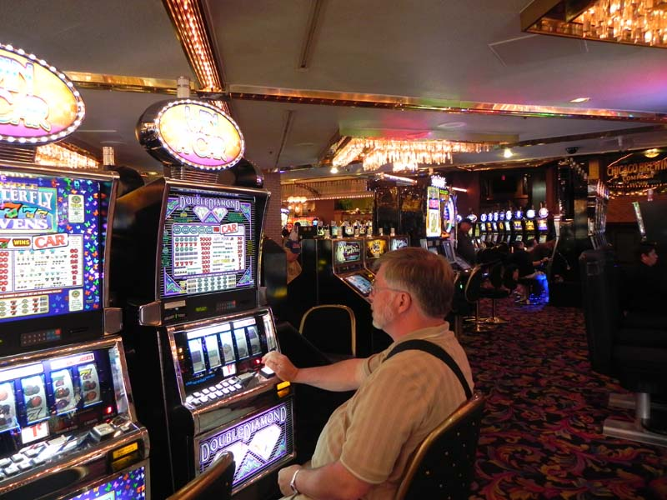

Marina left.
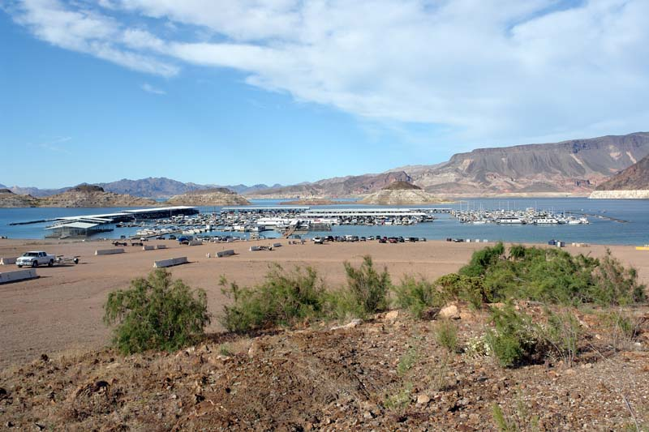

Marina right

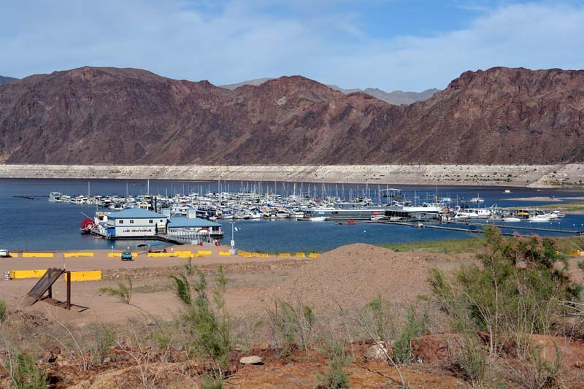

Wet work.



