So today we cooled our heels. We had breakfast at Wildflower Bread Company which is very much like Panera’s only better, and anyone who sells a breakfast sandwich (including Panera’s) could learn something from these people. We had no real plans so we kicked a few things around and decided to go look at some petroglyphs at the V-Bar-V Ranch. This is a few miles out into the back country but a neat ride so when we got to the gate and found that they are only open a few days of the week, today not being one of them, we weren’t real disappointed. It gave us time to explore and smell the roses, which in this case were cacti so you don’t want to get your nose too close on the smelling part. As a very wise woman once said, “There are no friendly plants …” in this area (right Debby?). Anyway, we rounded a corner on this dirt road and there were prickly pear everywhere.

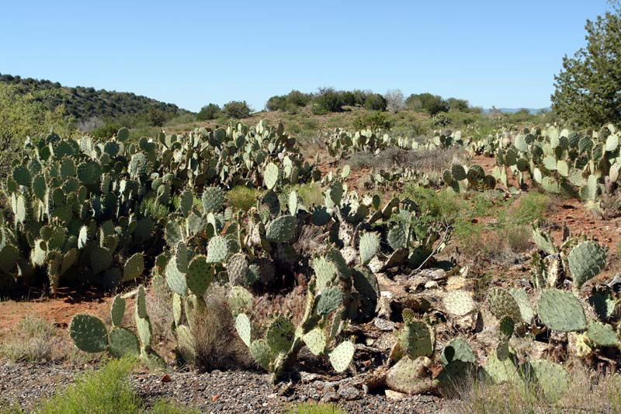

As we continued along we found them covering hillsides. Of course, Debby took tons of photos and I took not quite a ton but very many, nonetheless. Anyone would think we had never seen this before.

This photo is of Debby walking along a trail beside a dry creek bed and those things on the hillside are prickly pear.

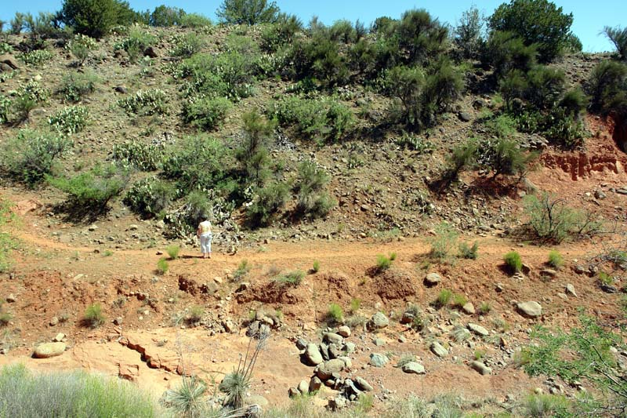

These things can be deadly!
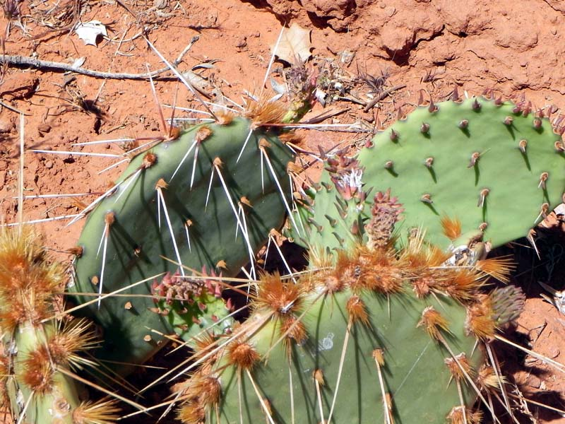
After the trip to the outback we had lunch at Shugrue’s (for those of you familiar with Sedona’s eateries). Debby had a Taco Salad and I had a half-pound cheeseburger with two kinds of cheese with guacamole and chili sauce on it. For the other “foodies” out there, this was lunch and it was great. The views from here are some of the best in Sedona (the video will be on my site later).

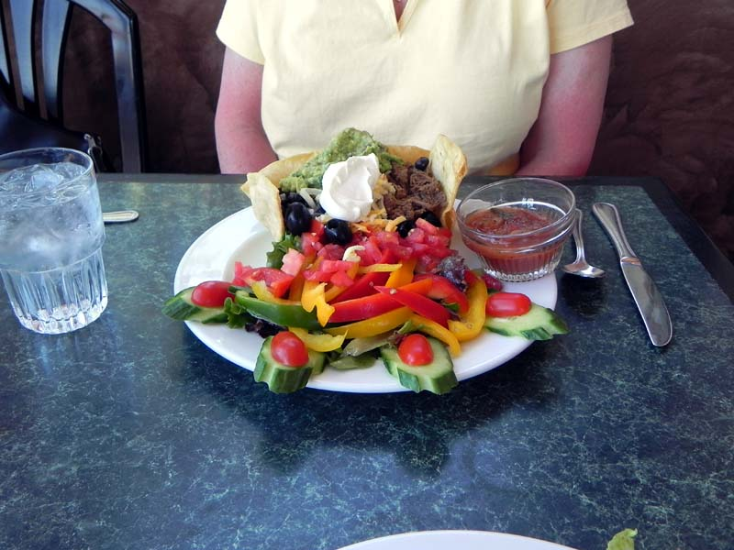

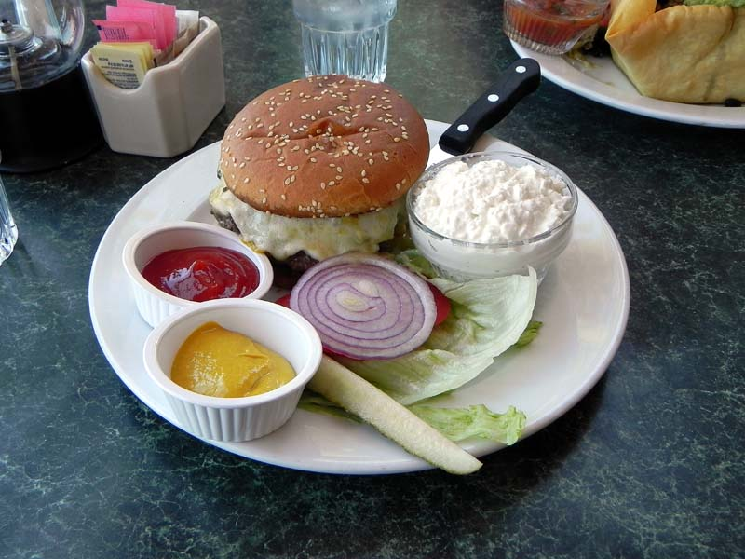

After lunch we revisited some of the scenic turnouts in the area to get more photos since we finally had a blue sky to work with. We revisited Bell Rock and hiked to the base (not much of a hike for most) and enjoyed the moment. Aaron, Rob and Judy, I spoke to you from the shade of the tree in the lower center.

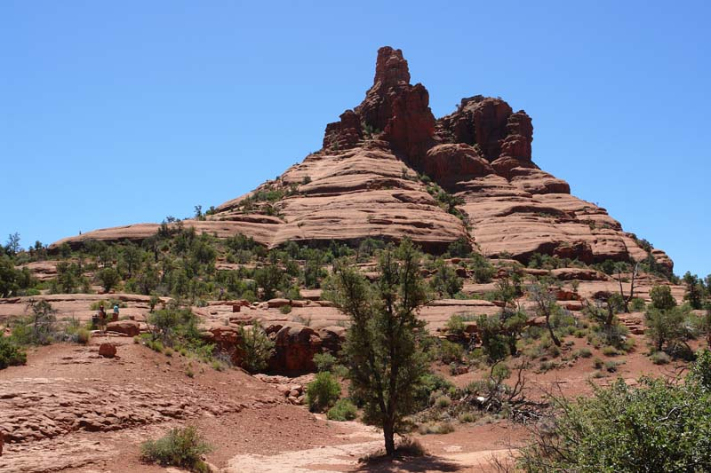

Other shots from the area (unfortunately in low-res). And the Grand Canyon tomorrow!



